Disc spring inquiry sheet
(Please copy and complete,mark with cross where applicable)

1.Kind of Machine:
2. Purpose of springs:
3.Installstion Space(max. and Length)

4.Type of load:○static ○dynamic
5.Loads and Deflections:
L1= mm f1= mm F1= mm
L2= mm f2= mm F2= mm
L3= mm f3= mm F3= mm

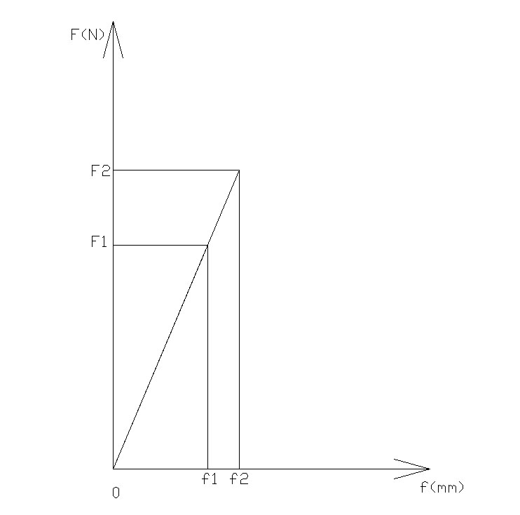
6.Guide: ○inner ○outer
7.Working Temperature (at the springs):
8.Number of Cycles Required:
9.Form of load: ○impact ○sinusoidal
10.Agressive Medium:
11.Position of the Spring Stack: ○vertical ○horizontal
12.Is corrosion protection necessary?
13.Remarks:

Compiled by:
Telephone: Fax:
Company,Signature:

Please contact with us for more details.

Mr.Hui Yang/Engineer Department
Xiamen Shuangyuan Springs Co.,Ltd
Tel: +86(592)5289710
Fax: +86(592)5513310

